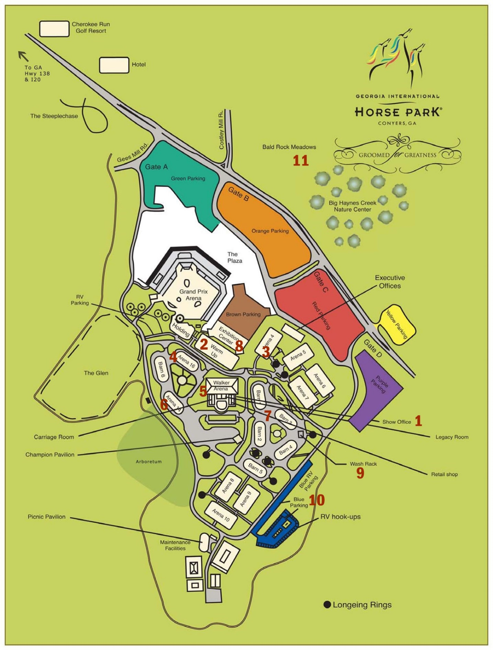

1 – Show Office, next to Walker Arena
2 – Cattle Arena
3 – Sheep Arena
4 – Jumpers Ring
5 – Walker Arena – Regular & Gamblers Rings
6 – Duck Arena
7 – Grooming Stall Bldgs – Barns 1-3
8 – Exhibition Center & Parking – Conformation, Obedience, Rally, Vendors
9 – Wash Rack
10 – RV Parking
11 – Tracking Fields

